BASH SCRIPTING – 01
1. Watch the video and write down notes.
2. Execute all scripts shown in video and capture the screenshots.
#!/bin/bash
# Simple output script
echo "Hello World"
Commands Executed :
vi HellWorld.bash
cat HelloWorld.bash
chmod 755 HellWorld.bash
./HellWorld.bash
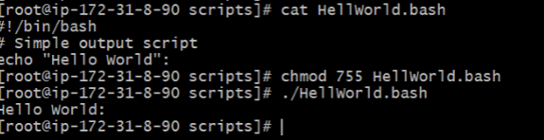

#!/bin/bash
# Define small tasks
Whoami
echo
pwd
echo
hostname
echo
ls -ltr
echo
Commands Executed:
vi Task.bash
cat Task.bash
chmod 755 Task.bash
./Task.bash
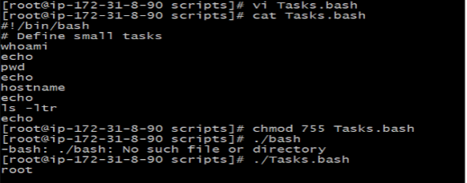
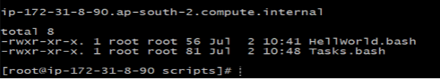
#!/bin/bash
# Read user input
echo "What is your first name?"
read a
echo
echo "What is your last name?"
read b
echo
echo Hello $a $b
Commands Executed:
vi userInput.bash
cat userInput.bash
chmod 755 userInput.bash
./userInput.bash
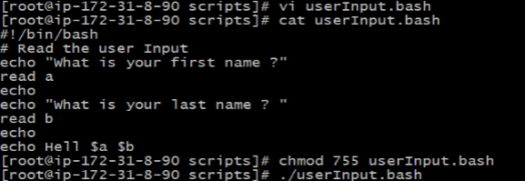
#!/bin/bash
# Script to run commands within
Clear
echo "Hello `whoami`"
echo
echo "Today is `date`"
echo
echo "Number of user login: `who | wc -l `"
echo
Commands Executed:
vi userdeatils.bash
cat userdeatils.bash
chmod 755 userdeatils.bash
./userdeatils.bash
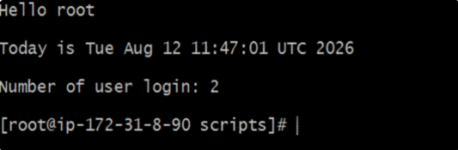
#!/bin/bash
echo "Enter the file name to be renamed"
read oldfilename
echo "Enter the new file name"
read newfilename
mv -- "$oldfilename" "$newfilename"
echo "The file has been renamed as $newfilename"
Commands Executed:
vi Rename.bash
cat Rename.bash
chmod 755 Rename.bash
./Rename.bash
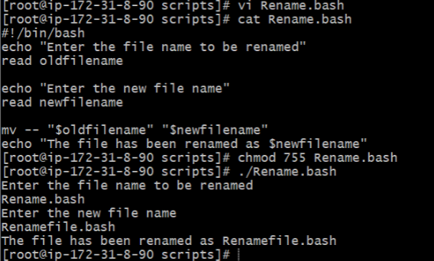

#!/bin/bash
Free -m
Ps -ef
df -h
du -sk
Commands Executed:
vi testing.bash
cat testing.bash
chmod 755 testing.bash
./testing.bash
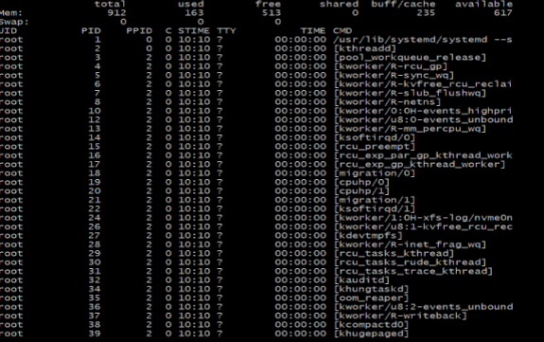

#!/bin/bash
whoami
date
cal 2026
Commands Executed:
vi commands.bash
cat commands.bash
chmod 755 commands.bash
./commands.bash
